ASSIGNMENT 4

## Producer-Consumer

#include <pthread.h>
#include <semaphore.h>
#include <stdlib.h>
#include <stdio.h>
#include <unistd.h>

#define MaxItems 5 // Maximum items a producer can produce or a consumer can consume
#define BufferSize 5 // Size of the buffer
#define MaxSize 5
sem_t empty;
sem_t full;
int in = 0;
int out = 0;
int buffer[BufferSize];
pthread_mutex_t mutex;

void *producer(void *pno)
{
int item;
for(int i = 0; i < MaxItems; i++) {
item = rand(); // Produce an random item
sem_wait(&empty);
pthread_mutex_lock(&mutex);
buffer[in] = item;
printf("Producer %d: produced %d\n", *((int *)pno),in);
in = (in+1)%BufferSize;
pthread_mutex_unlock(&mutex);
sem_post(&full);
}
}
void *consumer(void *cno)
{
for(int i = 0; i < MaxItems; i++) {
sem_wait(&full);
pthread_mutex_lock(&mutex);
int item = buffer[out];
printf("Consumer %d: consumed %d\n",*((int *)cno), out);
out = (out+1)%BufferSize;
pthread_mutex_unlock(&mutex);
sem_post(&empty);
}
}

int main()
{
int pn,cn;
pthread_t pro[5],con[5];
pthread_mutex_init(&mutex, NULL);
sem_init(&empty,0,BufferSize);
sem_init(&full,0,0);
printf("Enter No. of Producer: ");
scanf("%d",&pn);
printf("Enter No. of Consumer: ");
scanf("%d",&cn);
int cArr[MaxSize];
int pArr[MaxSize];
for(int i = 0; i < pn; i++) {
pArr[i]=i+1;
pthread_create(&pro[i], NULL, (void *)producer, (void *)&pArr[i]);
sleep(2);//optional by omkar
}
for(int i = 0; i < cn; i++) {
cArr[i]=i+1;
pthread_create(&con[i], NULL, (void *)consumer, (void *)&cArr[i]);
sleep(2);//optional by omkar
}

for(int i = 0; i < 5; i++) {
pthread_join(pro[i], NULL);
}

for(int i = 0; i < 5; i++) {
pthread_join(con[i], NULL);
}

pthread_mutex_destroy(&mutex);
sem_destroy(&empty);
sem_destroy(&full);

return 0;

}

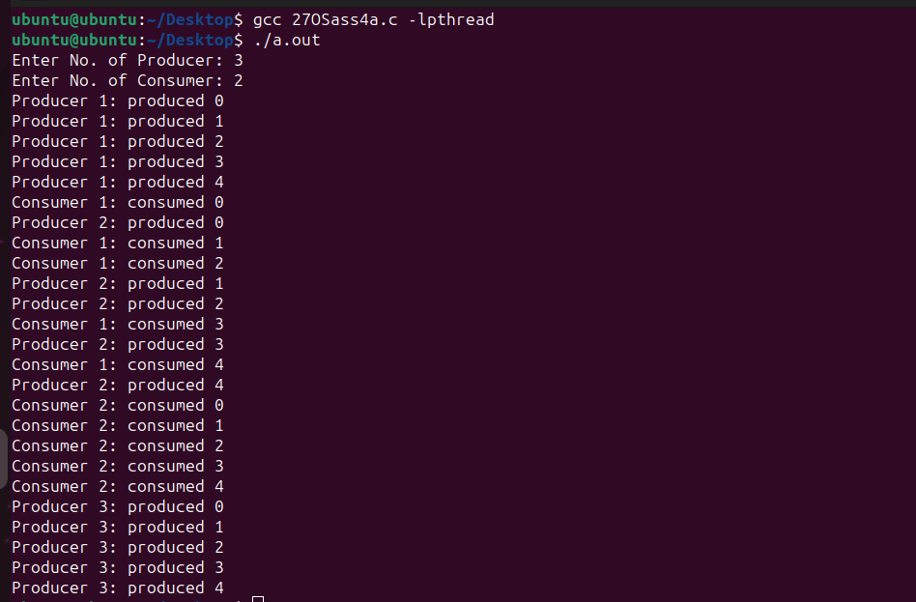

## Reader-Writer

#include <pthread.h>
#include <semaphore.h>
#include <stdio.h>
#include <unistd.h>
#include <stdlib.h>
#define MaxSize 5
#define MaxItems 5
#define BufferSize 5
sem_t wrt;
int in = 0;
int out = 0;
pthread_mutex_t mutex;
int buffer[BufferSize];
//int cnt = 1;
int numreader = 0;

void *writer(void *wno)
{
int item;
for(int i = 0; i < MaxItems; i++) {
int item;
item = rand();
sem_wait(&wrt);
buffer[in] = item;
printf("Writer %d writes count as %d\n",(*((int *)wno)),in);
in = (in+1)%BufferSize;
//cnt = cnt*2;
//printf("Writer %d writes count as %d\n",(*((int *)wno)),cnt);
sem_post(&wrt);
}

}
void *reader(void *rno)
{
// Reader acquire the lock before modifying numreader
pthread_mutex_lock(&mutex);
numreader++;
if(numreader == 1) {
sem_wait(&wrt); // If this id the first reader, then it will block the writer
}
pthread_mutex_unlock(&mutex);
// Reading Section
//printf("Reader %d: read count as %d\n",*((int *)rno),cnt);
for(int i = 0; i < MaxItems; i++) {
int item = buffer[out];
printf("Reader %d: read count as %d\n",*((int *)rno), out);
out = (out+1)%BufferSize;
}
// Reader acquire the lock before modifying numreader
pthread_mutex_lock(&mutex);
numreader--;
if(numreader == 0) {
sem_post(&wrt); // If this is the last reader, it will wake up the writer.
}
pthread_mutex_unlock(&mutex);
}

int main()
{
int pn,cn;
pthread_t read[10],write[5];
pthread_mutex_init(&mutex, NULL);
sem_init(&wrt,0,1);
printf("Enter No. of Writer: ");
scanf("%d",&pn);
printf("Enter No. of Reader: ");
scanf("%d",&cn);

int cArr[MaxSize];
int pArr[MaxSize];

for(int i = 0; i < pn; i++) {
pArr[i]=i+1;
pthread_create(&read[i], NULL, (void *)reader, (void *)&pArr[i]);
//sleep(2); BY KAUSTUBH NO DELETE
}
for(int i = 0; i < cn; i++) {
cArr[i]=i+1;
pthread_create(&write[i], NULL, (void *)writer, (void *)&cArr[i]);
//sleep(2); BY KAUSTUBH NO DELETE
}
for(int i = 0; i < 5; i++) {
pthread_join(write[i], NULL);
}

for(int i = 0; i < 10; i++) {
pthread_join(read[i], NULL);
}

pthread_mutex_destroy(&mutex);
sem_destroy(&wrt);

return 0;

}
